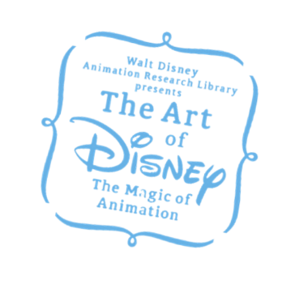 | The Art of Disney:  The Magic of Animation (DDP)  2019. 4. 19 – 8. 18  GNC Media Publicists: 안현웅 과장 (02-325-1085 / awoong@gncmedia.com)  허태인 대리 02-325-1085/ taein02@gncmedia.com)

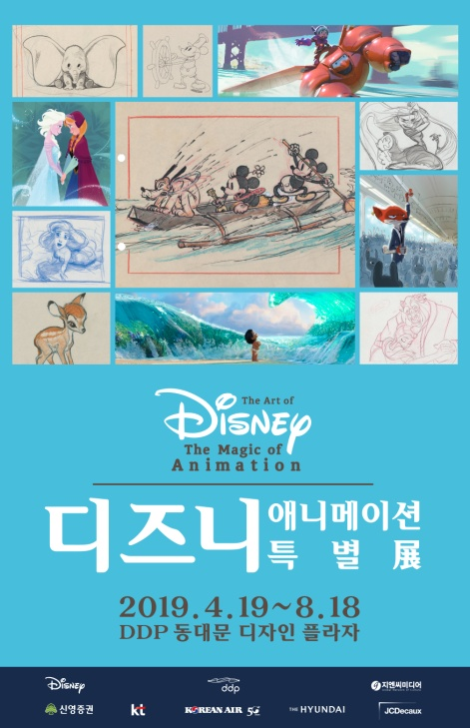 | Name :  Period:  Place:  Organizers : | The Art of Disney : The Magic of Animation  April 19, 2019 (Fri.) ~ August 18, 2019 (Sun.)  DDP (Dongdaemun Design Plaza) – Design Exhibition Hall  Walt Disney Animation Studios  Seoul Design Foundation  GNC Media

“Animation can explain whatever the mind of man can conceive.”
- Walt Disney

An exhibition of Disney art for all generations- from Mickey Mouse to FROZEN!
From the birth of Mickey Mouse in 1928 to Frozen 2, Disney studio have been giving lives to dream and imagination all over the world for about 100 years. A large scale exhibition showing the extensive history will be held at DDP of Seoul on April 19, 2019.

Introduction
Walt Disney Animation Research Library, Seoul Design Foundation, and GNC Media are holding ‘The ART of DISNEY: Magic of Animation’. Displayed from April 19 to August 18, the exhibition is a large-scale art exhibition of Disney with the history from Mickey Mouse to Frozen 2 (2019), releasing this year, giving lives to dreams and imaginations all over the world for about a century. From the classic works- Mickey Mouse, Pinocchio (1940), Dumbo (1941) to recent works such as Tangled (2010), Wreck-It Ralph (2012), Frozen (2013), about 500 pieces of hand drawings, sketches, concept arts, or 3D models made by Disney studio artists will be exhibited. It is expected to be a precious opportunity to face the moments of our friendly Disney characters becoming alive.

Key Points

An exhibition that all generations can enjoy together
Fluttering hearts by only mentioning the name, “DISNEY” is familiar to everyone. The movies of Disney have strong power that brings the hearts of all generations together. ‘The Art of Disney: The Magic of Animation’ is the largest-scale Disney exhibition held in Korea, covering the tastes of all generations about Disney movies by covering the vast history of the Walt Disney Studios from Mickey Mouse to Frozen 2 (2019), which will be released later this year.
Passing through all generations ― the parents, who have experienced “animated films” through Mickey Mouse, Pinocchio (1940), Bambi (1942) or Snow White and the Seven Dwarfs (1937), the young adults, who were enthusiastic with The Lion King (1994) and Tarzan (1999), children, who fell in love with Moana (2017) and Frozen 2 (2019), with high-tech graphic technology, can enjoy the exhibition all together. For the upcoming month of May, the family month and vacations, families visiting ‘The Art of Disney: The Magic of Animation’ will be deeply into the exhibition together beyond genres, generations, and tastes.

Various Enjoyments of artworks, music, videos, and experiences
In the exhibition, you can find many plentiful experiences including the historic original artworks, dimensional works, and about 30 video contents. Beautiful theme songs and magnificent background music from everywhere ― the exhibition hall, ticket office, and even in the art shop ― will entertain your ears through the exhibition, also maximizing your attention to it. In this Disney exhibition displayed in Korea, there are specially installed large-scale multimedia walls. The special effect videos with themes of symbols of major Disney movies were newly produced under supervision of the Walt Disney ARL of USA, creating the atmosphere being inside magical, fantastic backgrounds of the Disney movies. There are plenty of other experiences to fascinate the children visitors ― such as the huge zoetrope(a cylinder-shaped toy with a sequence of pictures on its inner surface which, when viewed through the vertical slits spaced regularly around it while the toy is rotated, produce an illusion of animation) that can understand the principles of early animations, the mirror of the jealous queen in Snow White and the Seven Dwarfs (1937) or the special photo zones which you can become the heroic character inside the backgrounds of movies. Also, there are the educational areas for adults, about revolutionary technologies of Disney which continuously developed for each new movie, and cinematic, pictorial artistry, and the detailed explanations of docents which increases the excitement of exhibition.

The very first open to the public in Korea, never to be seen again
Many unreleased artworks will be displayed for the first time in Korea. Recent movies of Disney, such as Ralph Breaks the Internet: Wreck-It Ralph 2 (2018), and Frozen 2 (2019), scheduled to be released this winter, with global attentions are artworks not displayed in the previous exhibitions, and it is their first time meeting the public in Korea. It would not be too much to say that 2019 is year of Disney, because many Disney movies are scheduled to be released including the live action movies, like Dumbo by Tim Burton, The Lion King, and also Frozen 2, other than ‘The Art of Disney: The Magic of Animation’. It would be a whole-series viewing through the centuries-old history of Disney at a glance, before watching the movies.
Composition
‘The ART of DISNEY: Magic of Animation’ is composed of five sections, covering the whole history of Disney from early short animations such as Mickey Mouse, Snow White and the Seven Dwarfs (1937), or Dumbo (1941), to Frozen 2, releasing in winter of 2019. You can find the philosophy of Disney at a glance, making dreams come true such as the birth of Walt Disney animation, main creators, and advance of the production technology. About 500 pieces of hand drawings, sketches, and 3D concept arts with high historical values and the production process videos and large-scale multimedia contents created exclusively for the exhibition can be found.

1. Bringing Creatures to Life
Walt Disney’s attempts to realize his dreams began with the creation of a believable virtual world populated by vibrant characters. Disney gave life to the characters through the harmony of natural movements of characters and sound effects, creating an innovation of animation technology.

2. The Magic Begins
The success of Snow White and The Seven Dwarfs (1937), world’s first feature-length cartoon film, led to the production of Pinocchio (1940), Fantasia (1940), Dumbo (1941), and Bambi (1942). To capture the rich and delicate movements of the animal characters and the beauty and severity of nature, the producers maintained precise observation and constant study. Based on these works, high-quality and realistic works were created.

3. Producers of Magic
Disney Studios were full of wonderful talents. Various sketches, concept arts, and background drawings of artists with their own styles constructed diverse and plentiful visual world of Disney animations. The development of production technology and experiences in the postwar world have spurred the high quality of Disney’s production of various works, and Disney films became a rich, plentiful symbol of American culture and art after the war.

4. Toward New Dimensions
In 1990s, the innovation of digital technology has largely inspired the artists of Disney who were always craving for something new. The computer graphic technology became a main measure for producing Disney animations. Collaborations with major musicians of the day and musical storytelling opened up a new possibility of the Disney films.

5. Bringing People Together
While the world is changing rapidly and Disney’s production techniques are also developing, the constant research and effort to create a perfect work is evident everywhere, from early work to recent work. Disney has always wanted to produce works that are close to reality, respecting diverse values of modern times and giving strong messages about the future world. The philosophy of Disney is bringing us into a new future, bringing life to everyone’s dreams and hopes for something new.

Information
Exhibition Title : The Art of Disney : The Magic of Animation
Organizers: Walt Disney Animation Studios, Seoul Design Foundation, GNC Media
Exhibition Period: April 19, 2019 (Fri.) – August 18, 2019 (Sun.) 10:00~20:00
* Ticket and Admission possible 1 hour before closing (19:00)
* Friday, Saturday, Sunday, and holidays open until 21:00
Exhibition Place : DDP(Dongdaemun Design Plaza) B2 Design Exhibition Hall
Admission Fee : General 15,000 KRW, Adolescent 13,000 KRW, Children 11,000 KRW
Docent Tours : 11:00, 13:00, 15:00, 17:00 (four times a day)
* Docent tours are held only in weekdays, can be cancelled due to congestion inside the hall
* Children docent tours will be held during the summer vacation period
Inquiry : 02-325-1077~8 / gnc@gncmedia.com
Representative Works : Attached Below

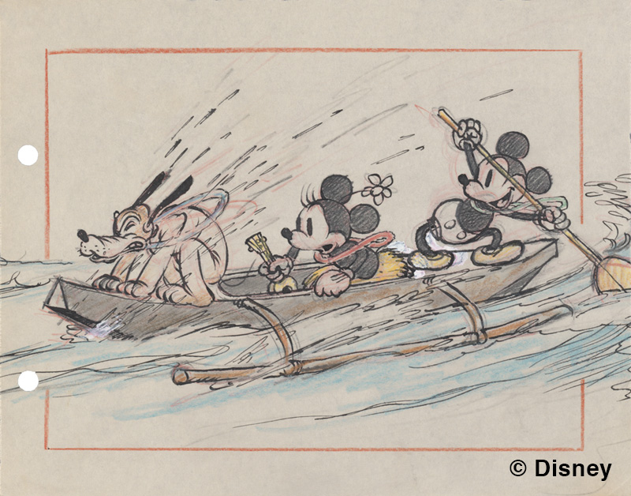 | ©Disney Enterprises, Inc  <그 여름의 하와이> 1937년  ≪Hawaiian Holiday≫ (1937)
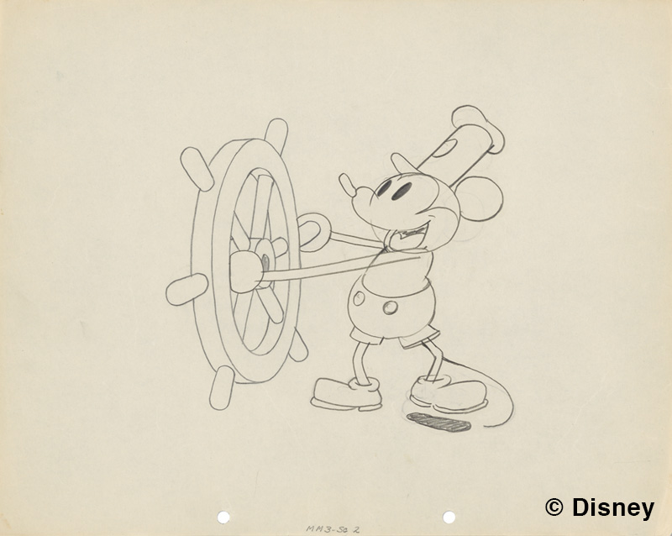 | ©Disney Enterprises, Inc  <증기선 윌리> 1928년  ≪Steamboat Willie≫ (1937)
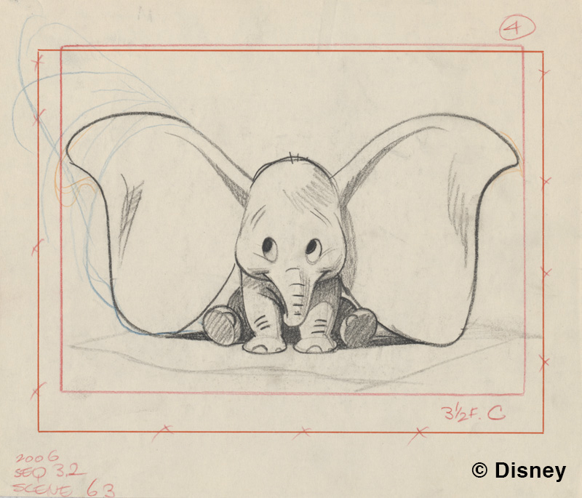 | ©Disney Enterprises, Inc  <덤보> 1941년  ≪Dumbo≫ (1941)
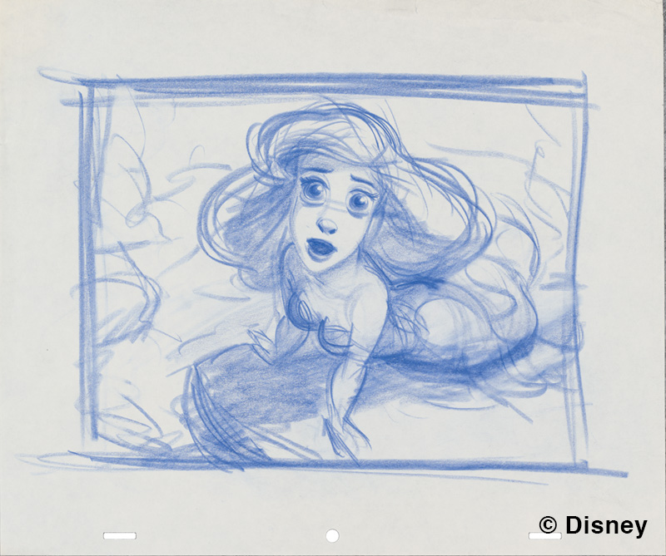 | ©Disney Enterprises, Inc  <인어공주> 1989년  ≪The Little Mermaid≫ (1989)
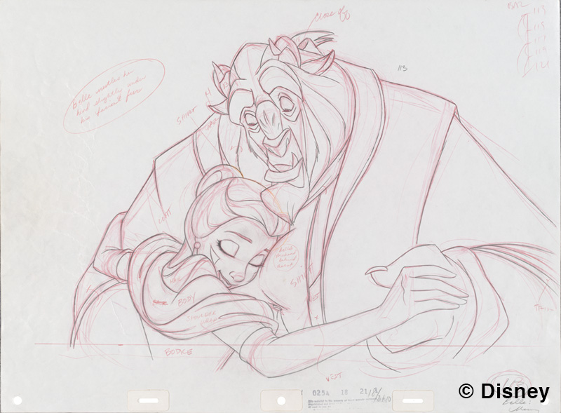 | ©Disney Enterprises, Inc  <미녀와 야수> 1991년  ≪Beauty and the Beast≫ (1991)
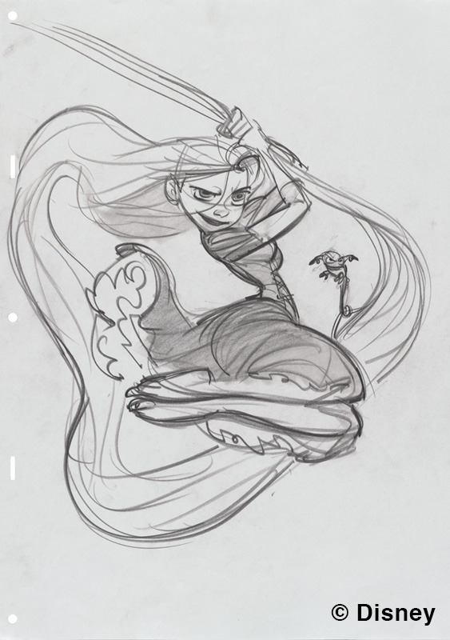 | ©Disney Enterprises, Inc  <라푼젤> 2010년  ≪Tangled≫ (2010)
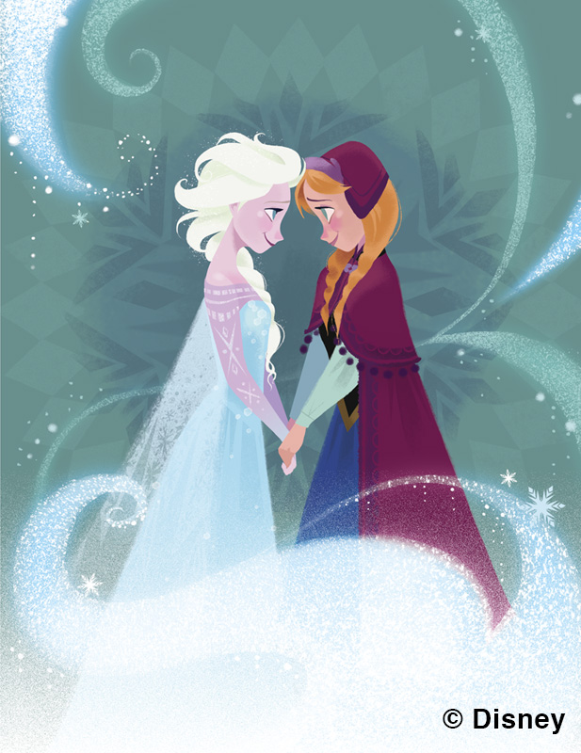 | ©Disney Enterprises, Inc  <겨울왕국> 2013년  ≪Frozen≫ (2013)
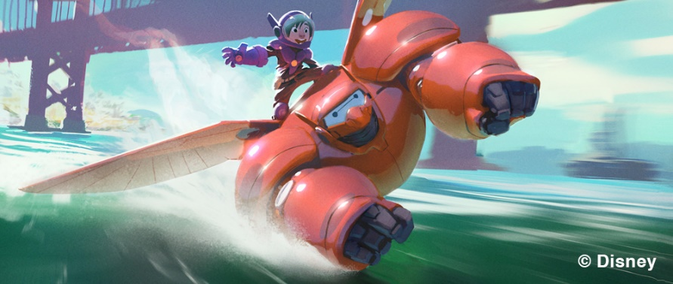 | ©Disney Enterprises, Inc  <빅 히어로> 2014년  ≪Big Hero 6≫ (2014)
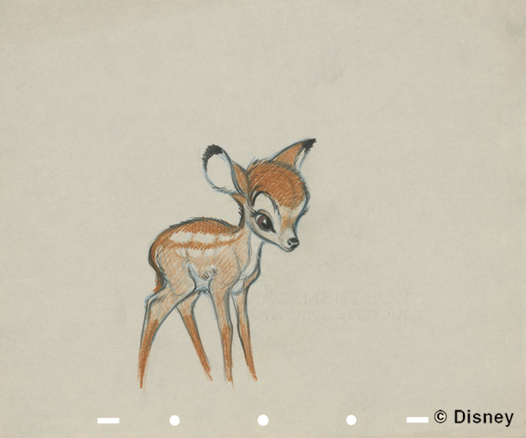 | ©Disney Enterprises, Inc  <밤비> 1942년  ≪Bambi≫ (1942)
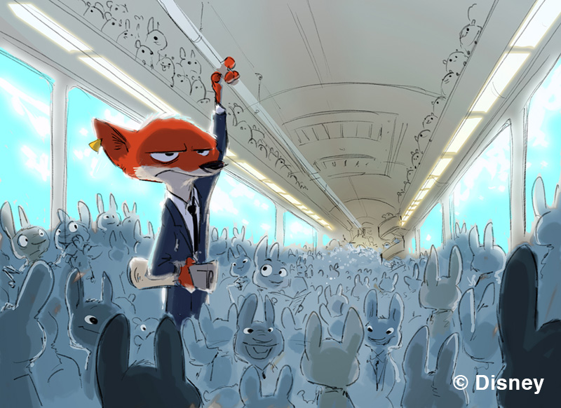 | ©Disney Enterprises, Inc  <주토피아> 2016년  ≪Zootopia≫ (2016)
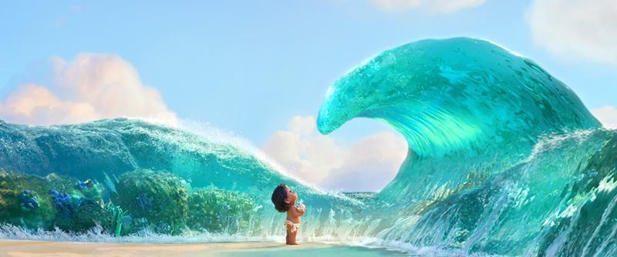 | ©Disney Enterprises, Inc  <모아나> 2016년  ≪Moana≫ (2016)
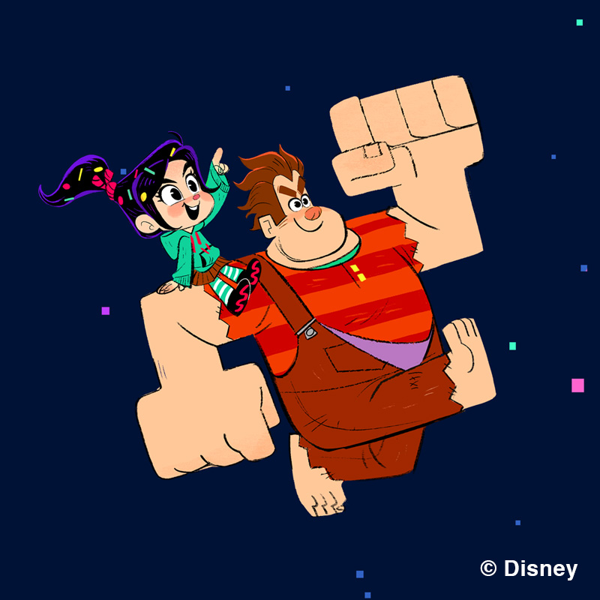 | ©Disney Enterprises, Inc  <주먹왕 랄프2: 인터넷 속으로> 2018년  ≪Ralph Breaks the Internet: Wreck-It Ralph 2≫ (2018)

